NAME: G. Yashmita REG NO: 192511032

(Git/Github)

EXPERIMENT 28:
You cloned a repository earlier, and now another collaborator has
made changes to it. You need to pull the latest changes from GitHub
to keep your local copy up to date.
Tasks:
• Clone a repository (from previous questions).
• Ask a collaborator to make a change and push it to the GitHub
repository.
• Use git pull origin main to pull the latest changes.
• Verify that the changes made by your collaborator appear in
your local repository.

Aim
To pull the latest changes made by a collaborator from a remote GitHub repository and update the local repository using Git.

Software Requirements
- Git
- GitHub
- Visual Studio Code
- Web Browser
- Internet Connection

Theory
Git allows multiple developers to work on the same project using a shared repository. When a collaborator makes changes and pushes them to the remote GitHub repository, other developers can obtain those latest changes using the git pull command.
The git pull origin main command retrieves the latest changes from the remote main branch and integrates them into the local repository. This helps keep the local copy synchronized with the remote repository.

Procedure

Step 1: Open the Cloned Repository
The previously cloned repository was opened in Visual Studio Code.
The repository directory was accessed using:
cd C:\Users\yashm\documents\sample-repo
The main branch was selected using:
git checkout main
The current repository status was verified using:
git status
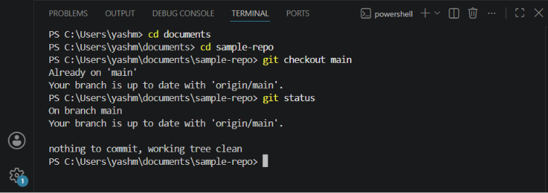

Step 2: Verify the Local Repository
The latest version of the repository was initially synchronized with the remote repository using:
git pull origin main
The repository was confirmed to be up to date.

Step 3: Make a Change as a Collaborator
A collaborator's change was simulated by modifying the README.md file directly in the GitHub repository.
The following content was added:
## Collaborator Update

This change was added by a collaborator.
The change was committed to the main branch of the remote repository.
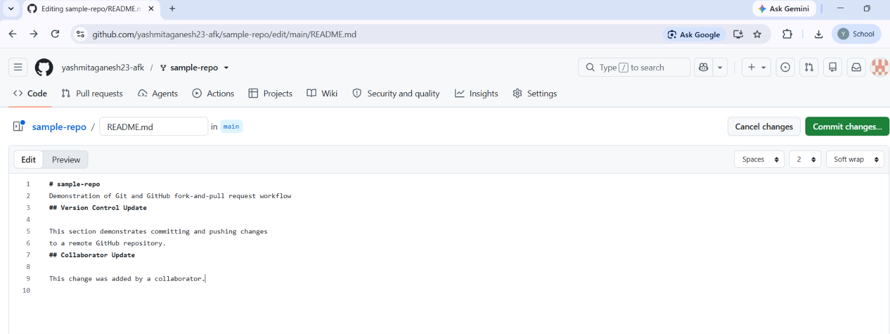
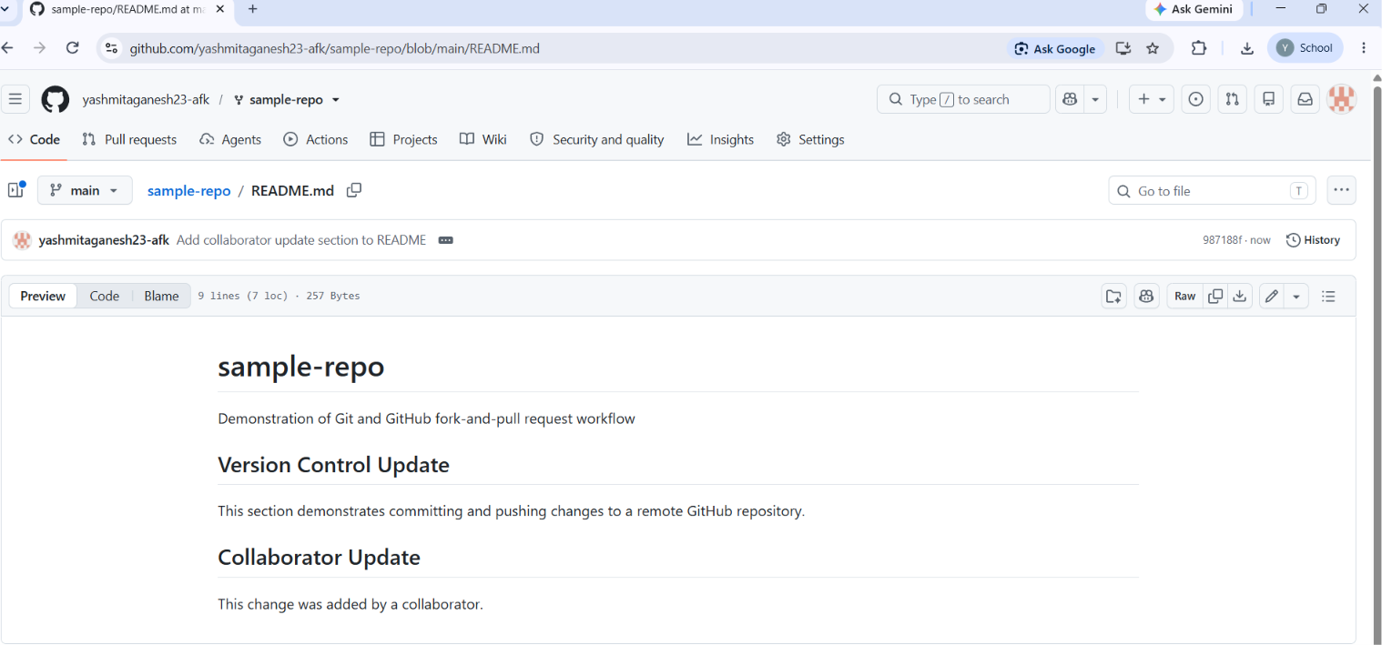

Step 4: Pull the Latest Changes
The local repository was updated using the following command:
git pull origin main
The command successfully retrieved the collaborator's latest changes.
The output indicated that the file was updated:
1 file changed, 4 insertions(+), 1 deletion(-)
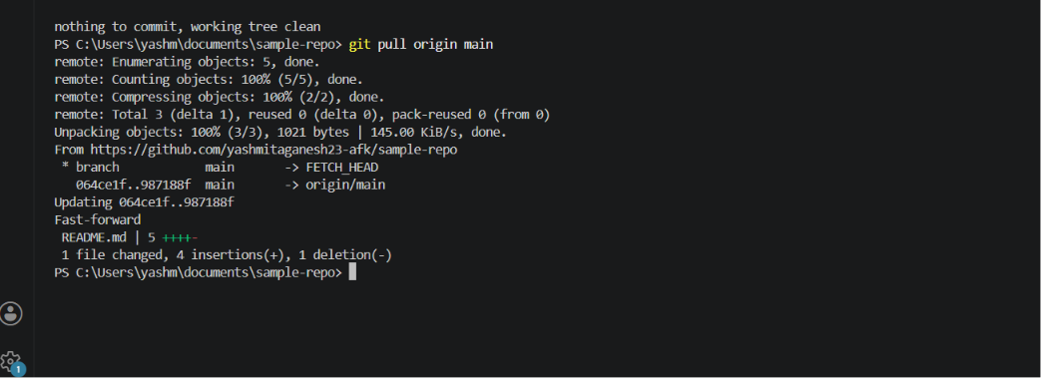

Step 5: Verify the Changes
The README.md file was opened in Visual Studio Code.
The changes made by the collaborator were verified in the local copy of the repository.
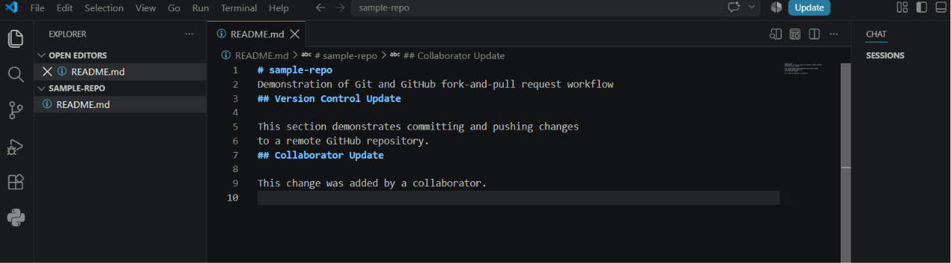

Step 6: Check Repository Status
The repository status was checked using:
git status
The following output was obtained:
On branch main
Your branch is up to date with 'origin/main'.

nothing to commit, working tree clean
This confirms that the local repository is synchronized with the remote repository.
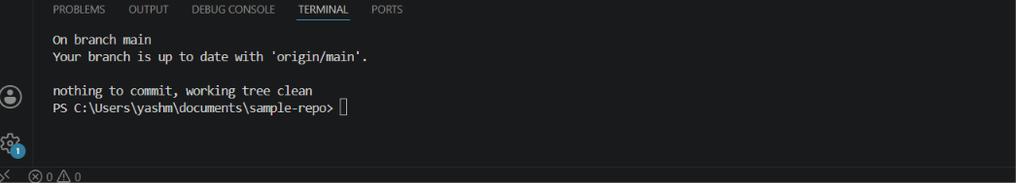

Commands Used
git checkout main
git status
git pull origin main
git status

Result
The latest changes made by a collaborator were successfully pulled from the GitHub repository using git pull origin main. The changes were verified in the local repository, and the local main branch was successfully synchronized with the remote repository.

